Use-Case Realization Report (Design)
Add Lesson

Issue <1.0>
Revision History
Date | Issue | Description | Author
29/11/09 | 1.0 | Initial Version | Rajendran Kumaraguru

Table of Contents
1. Brief Description 4
2. Flow of Events 4
2.1 Standard Flow 4
2.2 Exception Flow 4
3. Interaction Diagrams 5
3.1 Sequence Diagram for Add Lesson 5
4. Participating Objects 5
5. Class Diagrams 6
5.1 Class Diagram for Add Lesson 6
6. Derived Requirements 6

Use-Case Realization Report (Design)
Add Lesson

Brief Description
Upon creation of the company profile, portal admin will be able to create the lesson and this would be a first step in CMS in order to upload the content.

Flow of Events

Standard Flow
- Portal Admin log into the system, and go to Lesson Admin Page.
- By clicking the “btnAdd_Click” button, the CMS Site Maintenance will be called in order to create the site for the registered company.
- Company Details will be loaded into the system.
- Site Information will be fetched.
- Company information will be fetched from ACS,
- Validate fields will be validating the data field values before proceeding to check the duplicate folder check.
- Duplicate Folder will be checked before creating the site
- Duplicate site will be checked if there is any site which is already created.
- Site will be created
- Based on the above conditions the module master will be updated with newly created the site.
- New folder will be crated for the new site.
- Once the site is successfully created then message will be shown to portal admin for the success of the creation.

Exception Flow
- If there is a folder already exist system will throw the exception duplicate folder.
- If the site is already exist then system will throw the exception duplicate site.

Interaction Diagrams

Sequence Diagram for Add Lesson
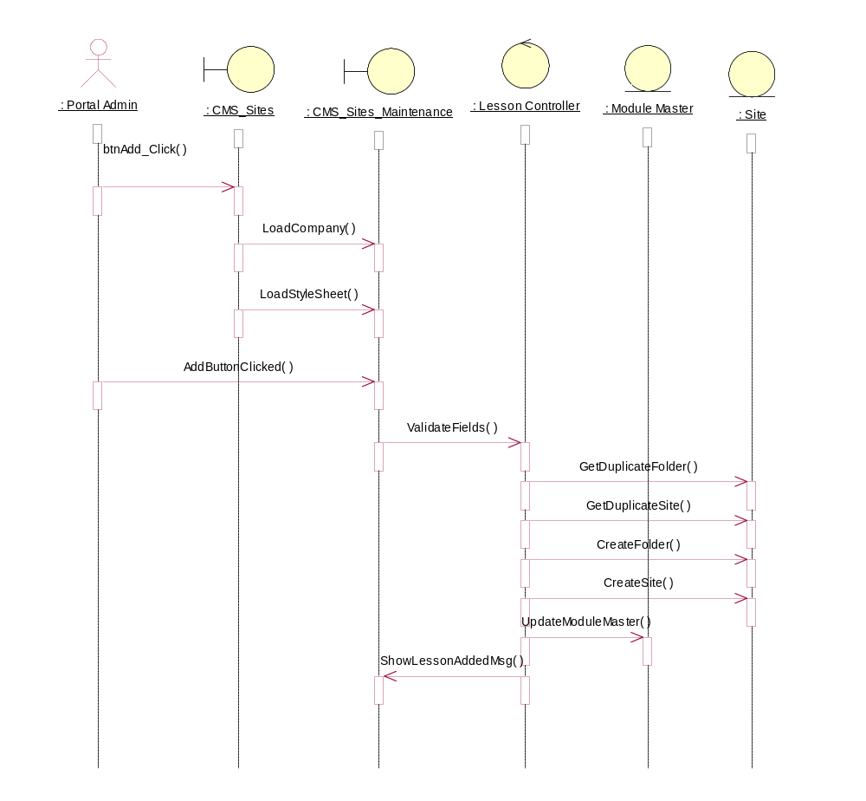

Participating Objects
: CMS_Sites

: CMS_Sites_Maintenance

: Lesson Controller

: Module Master

: Portal Admin

: Site

Class Diagrams

Class Diagram for Add Lesson
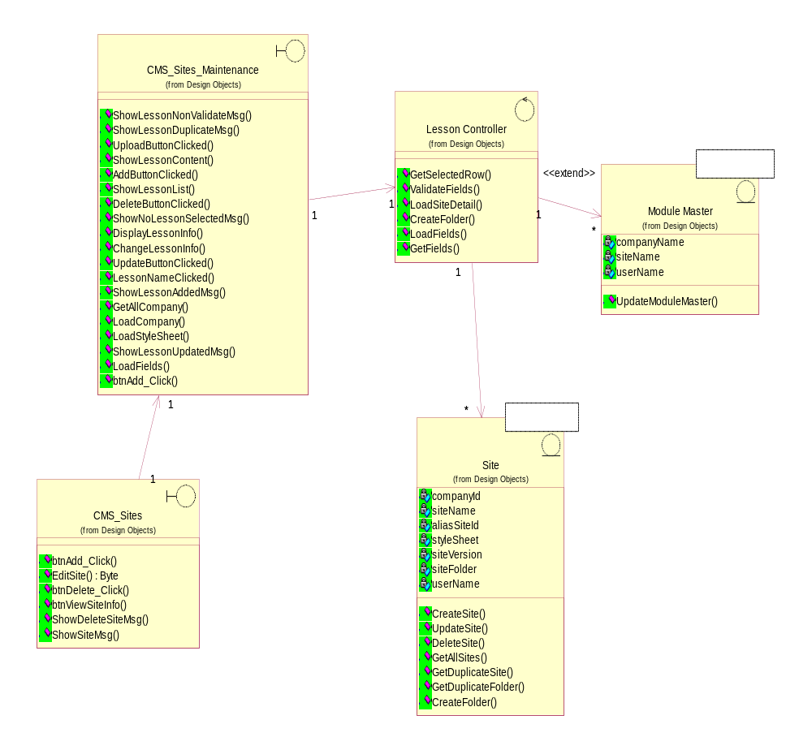

Derived Requirements
[enter the derived requirements here]

